Student worksheet

5.1 Classification organises our world

Student **worksheet**

Pages 80–81 and 192

Classification history

In the 4th century, a Greek philosopher called Aristotle classified all living things into two groups: plants and animals. His collection of ‘animals’ included giraffes, dragonflies and sharks. These animals he divided into three new groups based on how they moved. He called these groups walking (land), flying (air) or swimming (water).

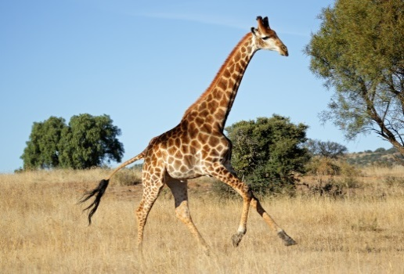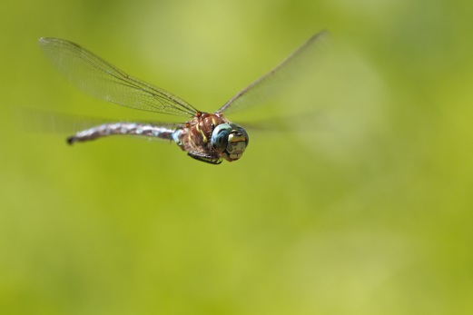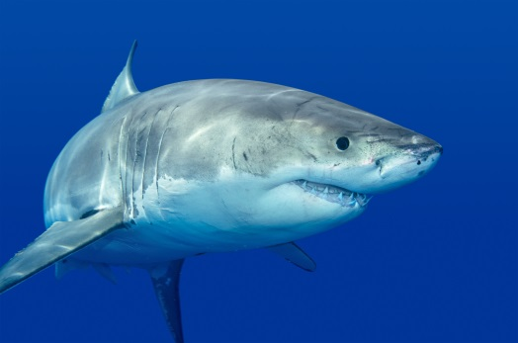

1 Draw a classification key that shows how Aristotle classified living things.

|  |
| --- |
|  |

2 Name two animals that would fit into the following groups:

a Walking \_\_\_\_\_\_\_\_\_\_\_\_\_\_\_\_\_\_\_\_\_\_\_\_\_\_\_\_\_\_\_\_\_\_\_\_\_\_\_\_\_\_\_\_\_\_\_\_\_\_\_\_\_\_\_\_\_\_\_\_\_\_

b Flying \_\_\_\_\_\_\_\_\_\_\_\_\_\_\_\_\_\_\_\_\_\_\_\_\_\_\_\_\_\_\_\_\_\_\_\_\_\_\_\_\_\_\_\_\_\_\_\_\_\_\_\_\_\_\_\_\_\_\_\_\_\_

c Swimming \_\_\_\_\_\_\_\_\_\_\_\_\_\_\_\_\_\_\_\_\_\_\_\_\_\_\_\_\_\_\_\_\_\_\_\_\_\_\_\_\_\_\_\_\_\_\_\_\_\_\_\_\_\_\_\_\_\_\_\_\_\_

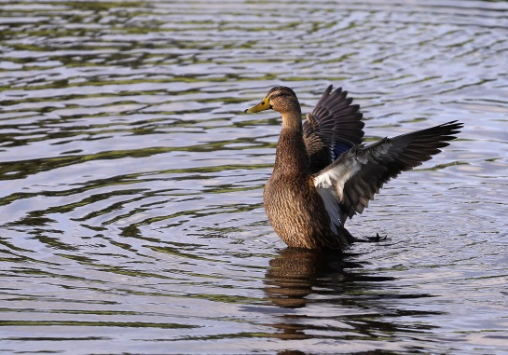3 In which of Aristotle’s groups would a duck belong? Provide evidence to support your opinion.

4 According to Aristotle, both bats and birds would be classified into the ‘flying’ group. Suggest a reason why these two animals should not be classified in the same group.

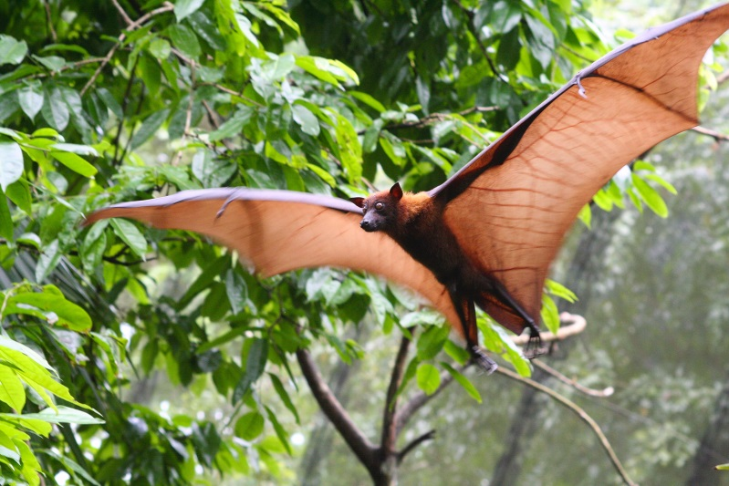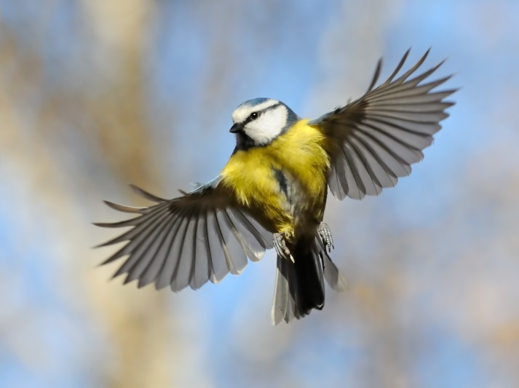

The current system of classification was suggested by Carl Linnaeus in the 18th century. It suggests a series of groups that become increasingly smaller.

5 Why did Linnaeus make changes to the classification system?

6 What changes did Linnaeus make?

7 What animals do you think these three classifications from Linnaeus’s classification system refer to?

a Quadrupedia: \_\_\_\_\_\_\_\_\_\_\_\_\_\_\_\_\_\_\_\_\_\_\_\_\_\_\_\_\_\_\_\_\_\_\_\_\_

b Aves: \_\_\_\_\_\_\_\_\_\_\_\_\_\_\_\_\_\_\_\_\_\_\_\_\_\_\_\_\_\_\_\_\_\_\_\_\_

c Amphibia: \_\_\_\_\_\_\_\_\_\_\_\_\_\_\_\_\_\_\_\_\_\_\_\_\_\_\_\_\_\_\_\_\_\_\_\_\_

EXTEND YOUR UNDERSTANDING

8 New species are discovered every year. Some of these are ancient species that are classified using fossil evidence, but other species are alive today. Research three new species that have been discovered this year. Find a picture of the species and write a two- or three-line description about each.

|  |  |
| --- | --- |
| Species | Image and description |
| 1 |  |
| 2 |  |
| 3 |  |

Student worksheet

5.2 Living organisms have characteristics in common

**Student worksheet**

Pages 82–83

Living or non-living?

In biology, we start to classify the things in the world according to whether they are living or non-living. Living things have special features that make them distinctly different from non-living things

1 All living things share eight key features. Complete the mnemonic (memory trick) below to outline the meaning of each feature. The first one has been done for you.

|  |  |
| --- | --- |
| M | **Movement: Living things can MOVE by themselves** |
| R |  |
| N |  |
| G |  |
| R |  |
| E |  |
| W |  |
| W |  |

2 Classify the following as living or non-living.

|  |  |  |  |  |  |
| --- | --- | --- | --- | --- | --- |
| a | a cat | \_\_\_\_\_\_\_\_\_\_\_\_\_\_\_\_\_\_\_\_\_\_\_ | e | salt | \_\_\_\_\_\_\_\_\_\_\_\_\_\_\_\_\_\_\_\_\_\_\_ |
| b | a drop of water | \_\_\_\_\_\_\_\_\_\_\_\_\_\_\_\_\_\_\_\_\_\_\_ | g | bacteria | \_\_\_\_\_\_\_\_\_\_\_\_\_\_\_\_\_\_\_\_\_\_\_ |
| c | an ant | \_\_\_\_\_\_\_\_\_\_\_\_\_\_\_\_\_\_\_\_\_\_\_ | h | grass | \_\_\_\_\_\_\_\_\_\_\_\_\_\_\_\_\_\_\_\_\_\_\_ |
| d | mould | \_\_\_\_\_\_\_\_\_\_\_\_\_\_\_\_\_\_\_\_\_\_\_ | i | computer | \_\_\_\_\_\_\_\_\_\_\_\_\_\_\_\_\_\_\_\_\_\_\_ |

3 Light a candle and observe the candle flame. Describe how it carries out each of the eight key features.

|  |  |
| --- | --- |
| M | **Movement: The flame flickers and moves** |
| R |  |
| N |  |
| G |  |
| R |  |
| E |  |
| W |  |
| W |  |

4 Based on your responses to the question above, decide whether you think a flame is living or non-living. Explain why.

EXTEND YOUR UNDERSTANDING

4 A recently-discovered species of Loricifera is missing an important characteristic that most animals and plants on Earth share. Use the Internet to find the answers to these questions:

• What are Loricifera?

• What is different about Loricifera compared with other animals?

• How do Loricifera survive without this characteristic?

Student worksheet

5.3 Classification keys are visual tools

Pages 84–85 and 193

Who am I?

1 Why do scientists use dichotomous keys?

2 Why is it important to classify things?

3 Name five characteristics that would help to classify the people in your class

4 On the next page is a dichotomous key for students in a Science class at *Stickman Secondary College.*

a Use the dichotomous key provided to identify the students in this class at *Stickman Secondary College* on the following page.

b Draw the missing students.

**Dichotomous key for students in a Science class at *Stickman Secondary College***

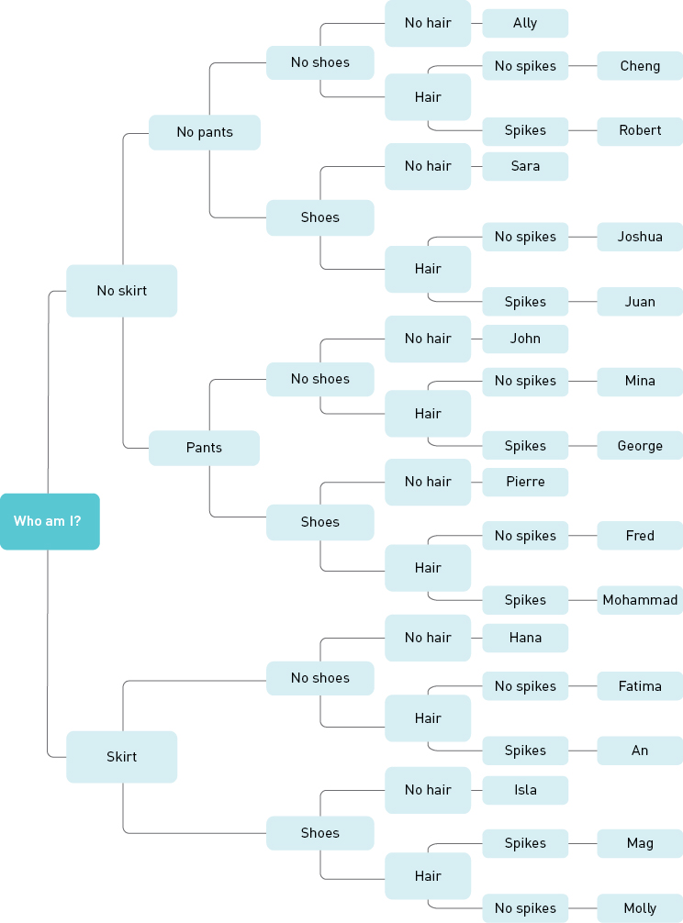

|  |  |  |  |  |  |
| --- | --- | --- | --- | --- | --- |
| A  WS0534_00876  \_\_\_\_\_\_\_\_\_\_ | B  WS0528_00876  \_\_\_\_\_\_\_\_\_\_ | C  WS0531_00876  \_\_\_\_\_\_\_\_\_\_ | D  WS0530_00876  \_\_\_\_\_\_\_\_\_\_ | E  WS0536_00876  \_\_\_\_\_\_\_\_\_\_ | F  WS0533_00876  \_\_\_\_\_\_\_\_\_\_ |
| G  WS0535_00876  \_\_\_\_\_\_\_\_\_\_ | H  WS0527_00876  \_\_\_\_\_\_\_\_\_\_ | I  WS0538_00876  \_\_\_\_\_\_\_\_\_\_ | J  WS0529_00876  \_\_\_\_\_\_\_\_\_\_ | K  WS0537_00876  \_\_\_\_\_\_\_\_\_\_ | L  WS0532_00876  \_\_\_\_\_\_\_\_\_\_ |
| M  \_\_\_\_\_\_\_\_\_\_ | N  \_\_\_\_\_\_\_\_\_\_ | O  \_\_\_\_\_\_\_\_\_\_ | P  \_\_\_\_\_\_\_\_\_\_ | Q  \_\_\_\_\_\_\_\_\_\_ | R  \_\_\_\_\_\_\_\_\_\_ |

EXTEND YOUR UNDERSTANDING

5 Use the Internet to find out the difference between bugs, beetles and insects. Summarise your findings in the table below.

|  |  |  |
| --- | --- | --- |
| Bugs | Beetles | Insects |
|  |  |  |

Student worksheet

5.4 Classification systems continue to change

Pages 86–87 and 194

Classification using seven levels

Each living thing can be classified according to the seven-level classification system: kingdom, phylum, class, order, family, genus and species. The largest grouping is the kingdom and the smallest is the species.

The genus and species are used together when referring to an organism. For example, humans are referred to as Homo sapiens. This is known as a binomial or scientific name.

This worksheet involves the classification of a range of living things using the table provided below.

|  |  |  |  |  |  |  |
| --- | --- | --- | --- | --- | --- | --- |
| Kingdom | Animalia | Animalia | Animalia | Animalia | Animalia | Animalia |
| Phylum | Chordata | Chordata | Arthropoda | Chordata | Chordata | Chordata |
| Class | Mammalia | Mammalia | Insecta | Reptilia | Aves | Actinopterygii |
| Order | Primates | Carnivora | Hymenoptera | Squamata | Galliformes | Scorpaeniformes |
| Family | Hominidae | Felidae | Apidae | Varanidae | Phasianidae | Scorpaenidae |
| Genus | Homo | Uncia | Apis | Varanus | Pavo | Pterois |
| Species | sapiens | uncia | mellifera | varius | cristatus | antennata |
| Common name | Human | Snow leopard | Honey bee | Lace monitor | Peacock | Lionfish |

1 Identify which level of classification contains the most number of organisms.

2 Identify which level contains the least number of organisms.

3 Which two species in the table above would be most similar? Explain why.

4 Which organism listed in the table above is most different to all the other organisms?

Early classification methods used the outside appearance of organisms to help classify them into groups. Modern techniques compare the genetic material (DNA) for similarities and differences. Organisms that have similar DNA are placed in the same group, while those with very different DNA are placed in different groups.

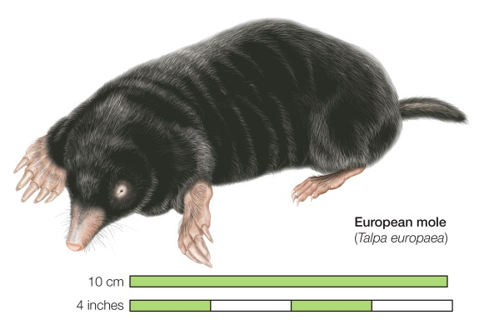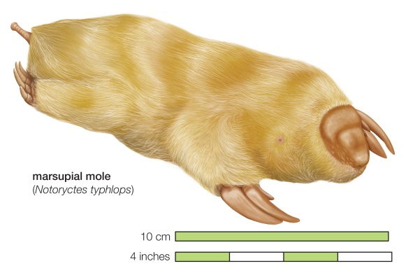

5 The two moles above look very similar. Describe three physical characteristics the moles have in common.

6 The DNA of these two moles is very different. Would you classify the moles in the same group or in different groups? Provide evidence to support your decision.

EXTEND YOUR UNDERSTANDING

7 Find out three other species from the same Genus as humans.

Student worksheet

5.5 All organisms can be organised into five Kingdoms

Pages 88–89 and 195

Kingdoms of life

The largest groupings in the classification system are the kingdoms. Features such as body form, type of cells and methods of obtaining nutrients are used to classify living things into groups.

| Kingdom | Body form and movement | Getting food | Examples | Number of known species |
| --- | --- | --- | --- | --- |
| Animalia | Multicellular with specialised eukaryotic cells. | Heterotrophic | Mammals, birds, reptiles, fish, amphibians, insects, worms, sponges | 9 812 298 |
| Plantae | Multicellular with specialised eukaryotic cells. Cells have a cell wall made of cellulose. | Autotrophic | Trees, flowering plants, conifers, mosses, ferns | 320 000 |
| Fungi | Multicellular, usually, with specialised eukaryotic cells. Cells have a cell wall made of chitin. | Heterotrophic | Fungi, moulds, mushrooms, yeasts, mildews | 1 500 000 |
| Monera | Tiny single-celled organisms with prokaryotic cells. Some form chains or mats or colonies. | Heterotrophic; a few are autotrophic | Bacteria, blue–green algae | 1 000 000 |
| Protista | Small single-celled organisms with a eukaryotic cell. Some form chains or colonies. Usually found floating in water. | Heterotrophic or autotrophic | Algae, amoebas, plankton, protozoans | 600 000 |

1 List the five main kingdoms.

2 Identify which of the kingdoms has the smallest number of known species.

3 Identify which of the kingdoms consists of unicellular organisms.

4 Explain how the members of the Kingdom Plantae differ from all other life forms.

5 Which of the kingdoms would be the most successful type of life form on Earth? Explain, giving reasons.

EXTEND YOUR UNDERSTANDING

Bacteria (Kingdom Monera) are the smallest living organisms on Earth. They are so small that a microscope is needed to see them. Despite this, they are not all the same: they come in all shapes and sizes. Each type of bacteria causes different diseases, so it is important that medical scientists are able to correctly identify them.

|  |  |  |  |
| --- | --- | --- | --- |
| Spherical bacteria are called ‘cocci’. | Spiral-shaped bacteria are called ‘spirillum’. | Longer rod-shaped bacteria are called ‘bacilli’. | Comma-shaped bacteria are called ‘vibrio’. |

|  |  |
| --- | --- |
| 6 A doctor sent a sample of bacteria found in a sore throat to the laboratory for testing. The scientist used a microscope to look at the sample and found cocci. Draw a picture of what the scientist saw down the microscope. |  |

7 Why was it important that the scientist identified the type of bacteria for the doctor?

There are two main types of spherical-shaped bacteria that could cause a throat infection, *Staphylococci* and *Streptococci*. Scientists must use a special stain called a Gram stain to tell these two stains apart. *Staphylococci* stain a purple colour with this stain and are called Gram positive; *Streptococci* do not stain purple and are called Gram negative.

8 Why do scientists sometimes need to stain bacteria cells?

9 *Staphylococci aureus* (also known as Golden Staph) is often resistant to many bacterial treatments like antibiotics. Why would it be important for hospitals to correctly identify these cells?

10 How are these cells different to cells in the Kingdom Animalia?

Student worksheet

5.6 Animals that have no skeleton are called invertebrates

Student **worksheet**

Pages 90–91 and 196–197

Butterfly or moth?

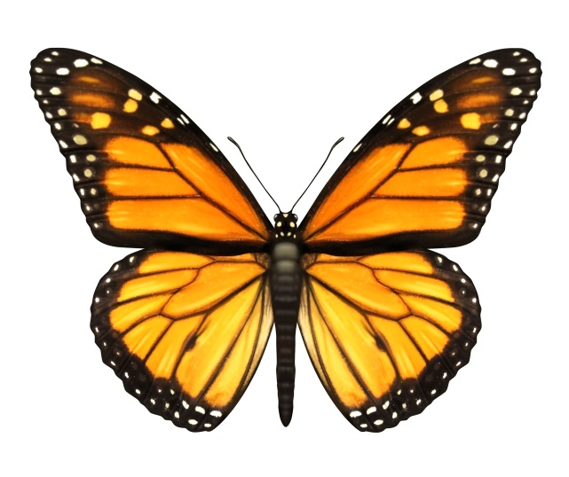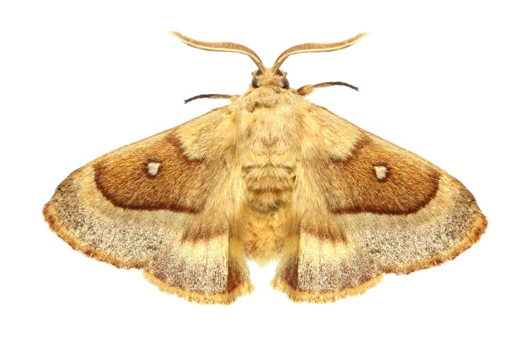

Butterflies and moths have many characteristics in common. Both are invertebrates, with exoskeletons, three body segments and wings covered with small scales. However, there are many general characteristics that can be used to classify them.

|  |  |  |
| --- | --- | --- |
| Characteristic | Butterfly | Moth |
| Antenna shape | Clubbed/lump on end | Feathery antennas that are not clubbed at the end |
| Wing structure | Four separate wings | Wings are linked together by bristle-like structures |
| Resting posture | Wings closed | Wings open |
| Forelegs | Smaller or missing forelegs | Fully developed forelegs |
| Active | Daytime | Night time |
| Colours | Usually bright colours | Usually dull colours |
| Cocoon or chrysalis | Chrysalis | Cocoon |

Both cocoons and chrysalides start as a caterpillar larva that eats the leaves of plants. When the caterpillars are ready, they form a protective covering around themselves as they become a pupa (the stage between the larva and adult). A moth makes a silken cocoon, whereas a butterfly makes a hard, smooth chrysalis.

1 What is an exoskeleton?

2 Both butterflies and moths are classified as insects. How can you tell the difference between insects and spiders?

3 Use the information provided above to draw the life cycle of a butterfly or a moth.

|  |
| --- |
|  |

4 Suggest a reason why a moth might have dull-coloured wings.

5 Use the characteristics listed above to draw a butterfly and a moth. Label the similarities and differences between them.

|  |  |
| --- | --- |
| Butterfly | Moth |

EXTEND YOUR UNDERSTANDING

6 Research a butterfly or moth that lives in your area.

• What characteristics could you use to identify it?

• Where does it live in your area?

• What is its life cycle?

• Does it migrate? If so, where to?

Student worksheet

5.7 Vertebrates can be organised into five classes

Pages 92–93 and 197

Classifying vertebrates

There are many different types of animals on Earth. The classification system is a way of ordering all the life forms so that we may better understand them. The kingdom is a large grouping; it can be broken down into a smaller grouping called a phylum. All the animals with a backbone or spinal column are in the phylum Chordata. These animals are commonly known as vertebrates.

1 Using your student book, list the five classes of vertebrates.

2 Decide whether each of the following statements is true or false.

a A kingdom is a bigger group than a phylum. \_\_\_\_\_\_\_\_\_\_\_\_\_\_\_\_\_\_\_\_

b All animals in Class Aves lay eggs. \_\_\_\_\_\_\_\_\_\_\_\_\_\_\_\_\_\_\_\_

c A cat is a endotherm. \_\_\_\_\_\_\_\_\_\_\_\_\_\_\_\_\_\_\_\_

d Turtles belong to Class Amphibia. \_\_\_\_\_\_\_\_\_\_\_\_\_\_\_\_\_\_\_\_

e A frog is an example of a reptile. \_\_\_\_\_\_\_\_\_\_\_\_\_\_\_\_\_\_\_\_

3 Describe what determines whether an animal is a vertebrate or an invertebrate.

4 What are the ttree subgroups of Class Mammalia? What is the feature used to separate these subgroups?

5 Complete the table below.

|  | Fish  (Class Pisces) | Amphibians  (Class Amphibia) | Reptiles  (Class Reptilia) | Birds  (Class Aves) | Mammals  (Class Mammalia) |
| --- | --- | --- | --- | --- | --- |
| Internal skeleton? |  |  |  |  |  |
| Ectotherm or endotherm? |  |  |  |  |  |
| Body covering? |  |  |  |  |  |
| Birth from egg or womb? |  |  |  |  |  |
|  | WS0541_00883 | WS0542_00883 | WS0545_00883 | WS0543_00883 | WS0544_00883 |

6 Complete the list of features for the vertebrate classes.

a \_\_\_\_\_\_\_\_\_\_\_\_\_\_\_\_ = Internal skeleton, endotherm, hair/fur, \_\_\_\_\_\_\_\_\_\_\_\_\_\_\_\_\_\_\_\_\_\_\_\_

b Birds = \_\_\_\_\_\_\_\_\_\_\_\_\_\_\_, \_\_\_\_\_\_\_\_\_\_\_\_\_\_\_, \_\_\_\_\_\_\_\_\_\_\_\_\_\_\_, \_\_\_\_\_\_\_\_\_\_\_\_\_\_\_

c \_\_\_\_\_\_\_\_\_\_\_\_\_ = Internal skeleton, ectotherm, \_\_\_\_\_\_\_\_\_\_\_\_\_, birth from eggs

d Fish = \_\_\_\_\_\_\_\_\_\_\_\_\_\_\_, \_\_\_\_\_\_\_\_\_\_\_\_\_\_\_, \_\_\_\_\_\_\_\_\_\_\_\_\_\_\_, \_\_\_\_\_\_\_\_\_\_\_\_\_\_\_

e \_\_\_\_\_\_\_\_\_\_\_\_\_\_\_\_\_\_\_\_\_\_\_\_\_\_\_\_\_\_\_\_ = Internal skeleton, ectotherm, moist skin, birth from eggs

EXTEND YOUR UNDERSTANDING

7 Construct ONE dichotomous key to classify ALL of the following animals:

labrador dog cat parrot pit bull terrier penguin shark kangaroo

Student worksheet

5.8 Plants can be classified according to their characteristics

Pages 94–95 and 198

Plants from the dinosaur age

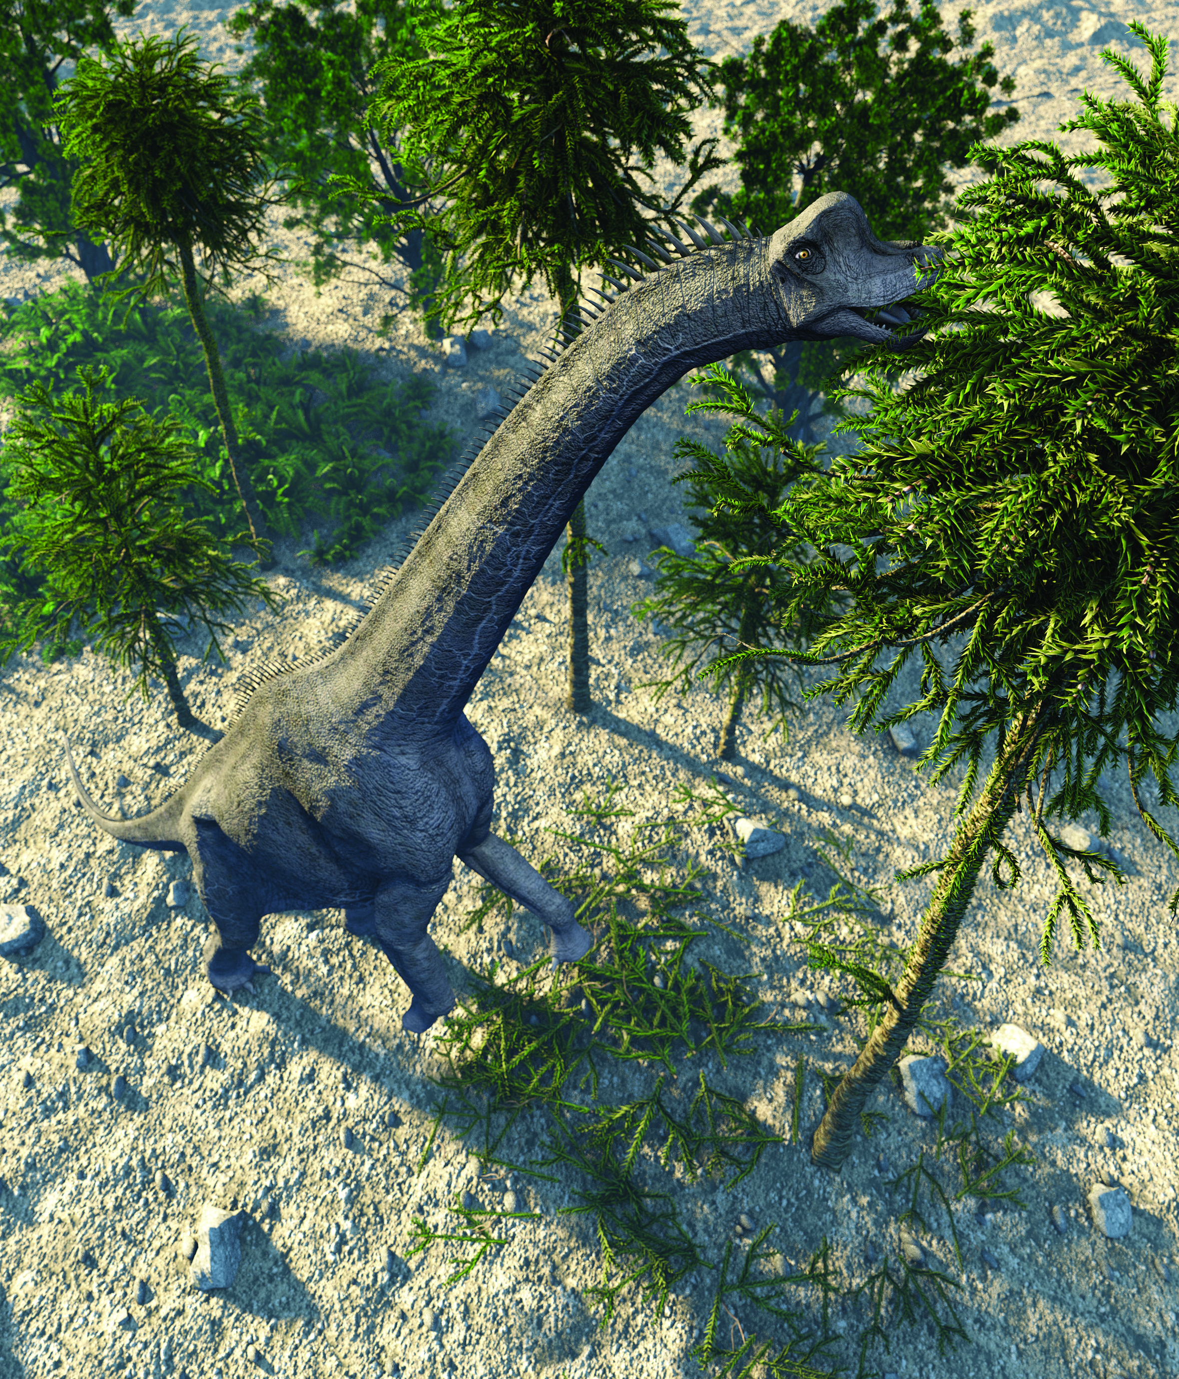In 1994, a bushwalker in the Wollemi National Park (just north of Sydney), noticed some large trees that he thought were different to any others he had seen before. He carefully removed a small branch and took it to a friend who was a botanist (expert in the study of plants). Initially the botanist thought the branch looked like leaves that could be found on a fern, and was surprised to be told it was from a tree that was 40 metres tall.

Careful studies of the tree revealed that it was very similar to the types of trees that existed millions of years ago. The tree was named *Wollemi nobelis* after the Wollemi National Park (where it was found) Mr William Nobel (the bushwalker who discovered it).

1 Pine trees belong to a group of plants called conifers. What are the characteristics that can be used to identify these plants?

2 One of the distinguishing characteristics of the Wollemi pine tree is its bark, which was once described as looking like it was ‘covered in Coco Pops’. Can you use more scientific terms to describe what this might look like?

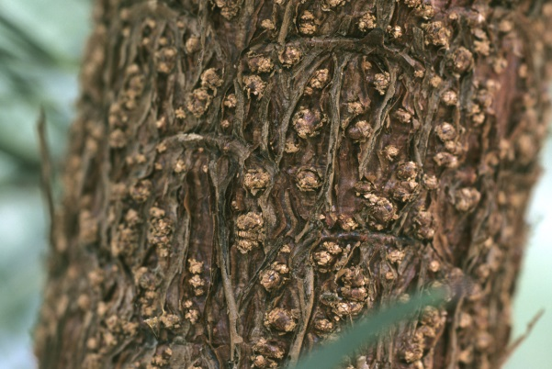

3 The Wollemi pine has large seeds that have been described as ‘wings’. How might these seeds be spread into new areas?

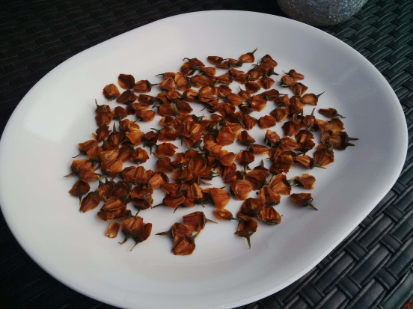

4 How might the Brachiosaurus (the dinosaur shown in the picture on the previous page) help with the dispersal of the Wollemi pine seeds? (Look at what the Brachiosaurus is doing.)

5 What might the Brachiosaurus provide to help the Wollemi pine seeds grow? (Think about what we add to plants to give them nutrients to help them grow).

6 Why is it important for seeds to move away from the parent tree before growing?

7 To revise some of the terms used in this section, write the definition of the following words:

a spore

b vascular tissue

c pollination

d monocots

e dicots

EXTEND YOUR UNDERSTANDING

8 Use the Internet to research the discovery of the Wollemi pine. What made it such an exciting discovery?

Student worksheet

5.9 Science as a human endeavour: The first Australian scientists classified their environment

Pages 96–97

Aboriginal medicines

|  |  |
| --- | --- |
| In the same way that Indigenous Australians classified their environment, they also classified and built up a thorough knowledge of bush medicine – recognising the characteristics of different plants and understanding how they could be used to treat illnesses. When European scientists arrived in Australia, they learned many things from the traditional landowners. | |
| WS0523_00876-rf | Tea tree oil (Melaleuca alternifolia)  The oil or paste from the bark or leaves of the tea tree can be used to kill some fungal or bacterial infections. |
| WS0524_00876 | Kakadu plum (Terminalia ferdinandiana)  This fruit has 50 times more vitamin C than an orange. A lack of vitamin C can result in weakened bones and a weakened immune system. |
| WS0525_00876-rf | Emu bush (Eremophila sp.)  Pastes made with the leaves of this plant have been used to wash cuts and scrapes by Indigenous communities in the Northern Territory. Recent research suggests that the emu bush has antimicrobial properties. |
| WS0526_00876-rf | Eucalyptus (Eucalyptus sp.)  Kino is a red-coloured sap or gum that has been tested by scientists for its ability to kill bacteria. Indigenous communities used kino to treat burns, eye infections and toothache. |

1 When testing a plant for the first time, early scientists did not put it in their mouth. Instead, they would rub a small amount on their skin. Suggest one reason why they tested plants in this way.

2 Why might scientists prefer to use the scientific names for the plants rather than their traditional (or common) names?

3 Suggest two advantages and two disadvantages of traditional medicines.

EXTEND YOUR UNDERSTANDING

4 Research one plant found in your state that was used by Indigenous Australians for food or medicine.